SUBJECT: Disparities in Cardiovascular Mortality Among Long-Term Ovarian Cancer Survivors: A Competing Risk Analysis.
DATASET: SEER Registry (2000-2016) | N = 38,148
Study details: This study used data from SEER records of patients diagnosed with cancer between 2000 and 2016, aged ≥ 20 years. The sample size for this study period was 6,412,621 patients. However, the study was focused on long-term ovarian cancer survivors and of our total sample size, only 38,148 patients were long-term survivors. The inclusion criteria for long-term survivors were patients who had survived ≥ 60 months (5+ years%). Table 1 shows the demographic and clinical characteristics of these long-term survivors.

Table 1: Overall Demographic and Clinical Characteristics of Long-term Ovarian Cancer Survivors (5+ years) (Grouped by Treatment Type)
Characteristic | Overall Cohort (n = 38,148) | Surgery Only (n = 12,212) | Surgery + Chemotherapy (n = 24,106) | Chemotherapy Alone (n = 750) | P-value
Age at Diagnosis, mean (SD) | 54.0y (13.8y) | 52.0 (15.0y) | 54.6y (12.9y) | 62.2y (13.9y) | <0.001
Age Group, n (%) |  |  |  |  | <0.001
20 - 39 years | 4,401 (11.5%) | 2,063 (16.9%) | 2,157 (8.9%) | 39 (5.2%)
40 - 59 years | 18,403 (48.2%) | 5,914 (48.4%) | 11,826 (49.1%) | 218 (29.1%)
60 - 79 years | 13,811 (36.2%) | 3,643 (29.8%) | 9,397 (39.0%) | 396 (52.8%)
80+ years | 1,533 (4.0%) | 592 (4.8%) | 726 (3.0%) | 97 (12.9%)
Race/Ethnicity, n (%) |  |  |  |  | <0.001
Non-Hispanic White | 26,821 (70.3%) | 8,317 (68.1%) | 17,299 (71.8%) | 512 (68.3%)
Non-Hispanic Black | 2,285 (6.0%) | 844 (6.9%) | 1,216 (5.0%) | 85 (11.3%)
Hispanic (All Races) | 5,048 (13.2%) | 1,726 (14.1%) | 3,071 (12.7%) | 96 (12.8%)
Asian / Pacific Islander | 3,652 (9.6%) | 1,198 (9.8%) | 2,333 (9.7%) | 45 (6.0%)
American Indian / Alaska Native | 237 (0.6%) | 72 (0.6%) | 148 (0.6%) | 9 (1.2%)
Other/Unknown | 105 (0.3%) | 55 (0.5%) | 39 (0.2%) | 3 (0.4%)
Median Household Income, n (%) |  |  |  |  | 0.001’
< $60,000 | 3,872 (10.1%) | 1,243 (10.2%) | 2,348 (9.7%) | 98 (13.1%)
$60,000 - $99,999 | 25,664 (67.3%) | 8,212 (67.2%) | 16,260 (67.5%) | 506 (67.5%)
$100,000+ | 8,606 (22.6%) | 2,757 (22.6%) | 5,493 (22.8%) | 145 (19.3%)
Unknown/Missing | 6 (0.0%) | 0 (0.0%) | 5 (0.0%) | 1 (0.1%)
Geography (Rural/Urban), n (%) |  |  |  |  | 0.527’
Urban (Metropolitan) | 34,226 (89.7%) | 10,967 (89.8%) | 21,671 (89.9%) | 673 (89.7%)
Rural (Nonmetropolitan) | 3,889 (10.2%) | 1,239 (10.1%) | 2,410 (10.0%) | 76 (10.1%)
Unknown/Missing | 33 (0.1%) | 6 (0.0%) | 25 (0.1%) | 1 (0.1%)
Cancer Stage, n (%) |  |  |  |  | <0.001
Localized | 11,086 (29.1%) | 7,063 (57.8%) | 3,905 (16.2%) | 19 (2.5%)
Regional | 11,478 (30.1%) | 3,121 (25.6%) | 8,191 (34.0%) | 87 (11.6%)
Distant | 14,107 (37.0%) | 1,639 (13.4%) | 11,677 (48.4%) | 554 (73.9%)
Unknown/unstaged | 1,477 (3.9%) | 389 (3.2%) | 333 (1.4%) | 90 (12.0%)
y years, SD standard deviation

Statistical comparisons (p-values) are restricted to women who received standard-of-care primary treatment modalities. The Overall column includes 1,080 additional patients who were excluded from the comparative subgroups due to receiving no active treatment or having missing therapeutic data. Continuous variables (Age at Diagnosis) are presented as Mean (SD), calculated using one-way analysis of variance (ANOVA). Categorical variables presented as absolute counts n, and percentages (%) were calculated using the Pearson’s Chi-square test.

Table 1: Overall characteristics of 5+ years female breast cancer survivors, (Grouped by Laterality%)

1. Overall Cumulative Incidence of Cardiovascular Mortality at 215 Months Among Long-Term Female Breast Cancer Survivors
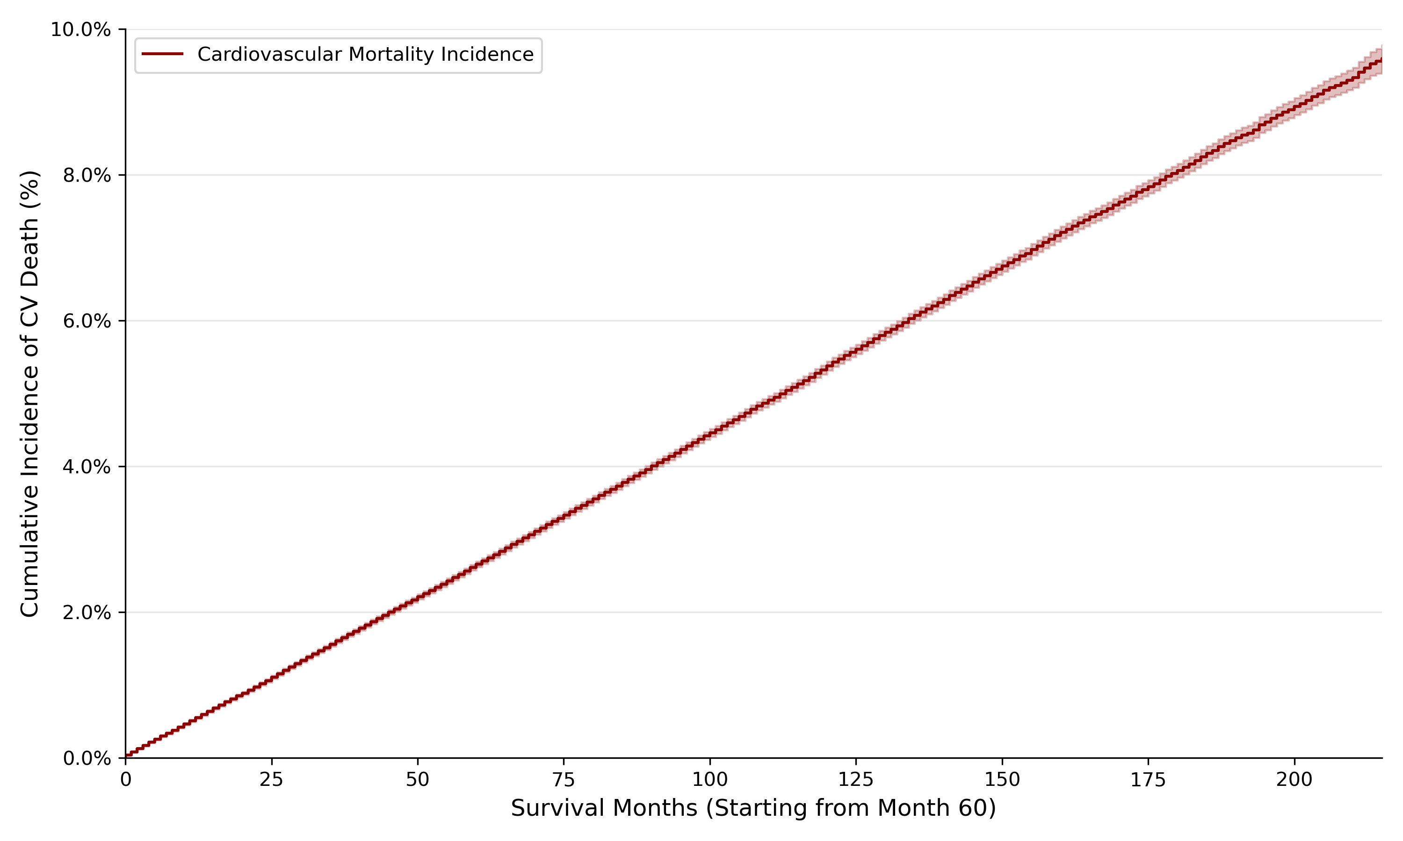
Figure 1: Overall Cumulative Incidence of Cardiovascular Death in Long-Term Female Breast Cancer Survivors
Overall Sample Size: 747,789
Censored / Alive (Event 0%): 540,876
CV Deaths (Event 1%): 35,070
Cancer Deaths (Event 2%): 88,024
Other Non-Cancer Deaths (Event 3%): 83,819

Cumulative Incidence at Year 10 (60 months post-milestone%): 2.64%
Cumulative Incidence at Year 15 (120 months post-milestone%): 5.35%
Cumulative Incidence at Year 20 (180 months post-milestone%): 8.03%
Cohort | Cumulative Incidence (95% CI%) | Standard Error
Overall (n=747,789%) | 9.63% (9.43%–9.82%%) | 0.001

2. Cumulative Incidence of Cardiovascular Mortality Among Long-Term Ovarian Cancer Survivors, by Age at Diagnosis
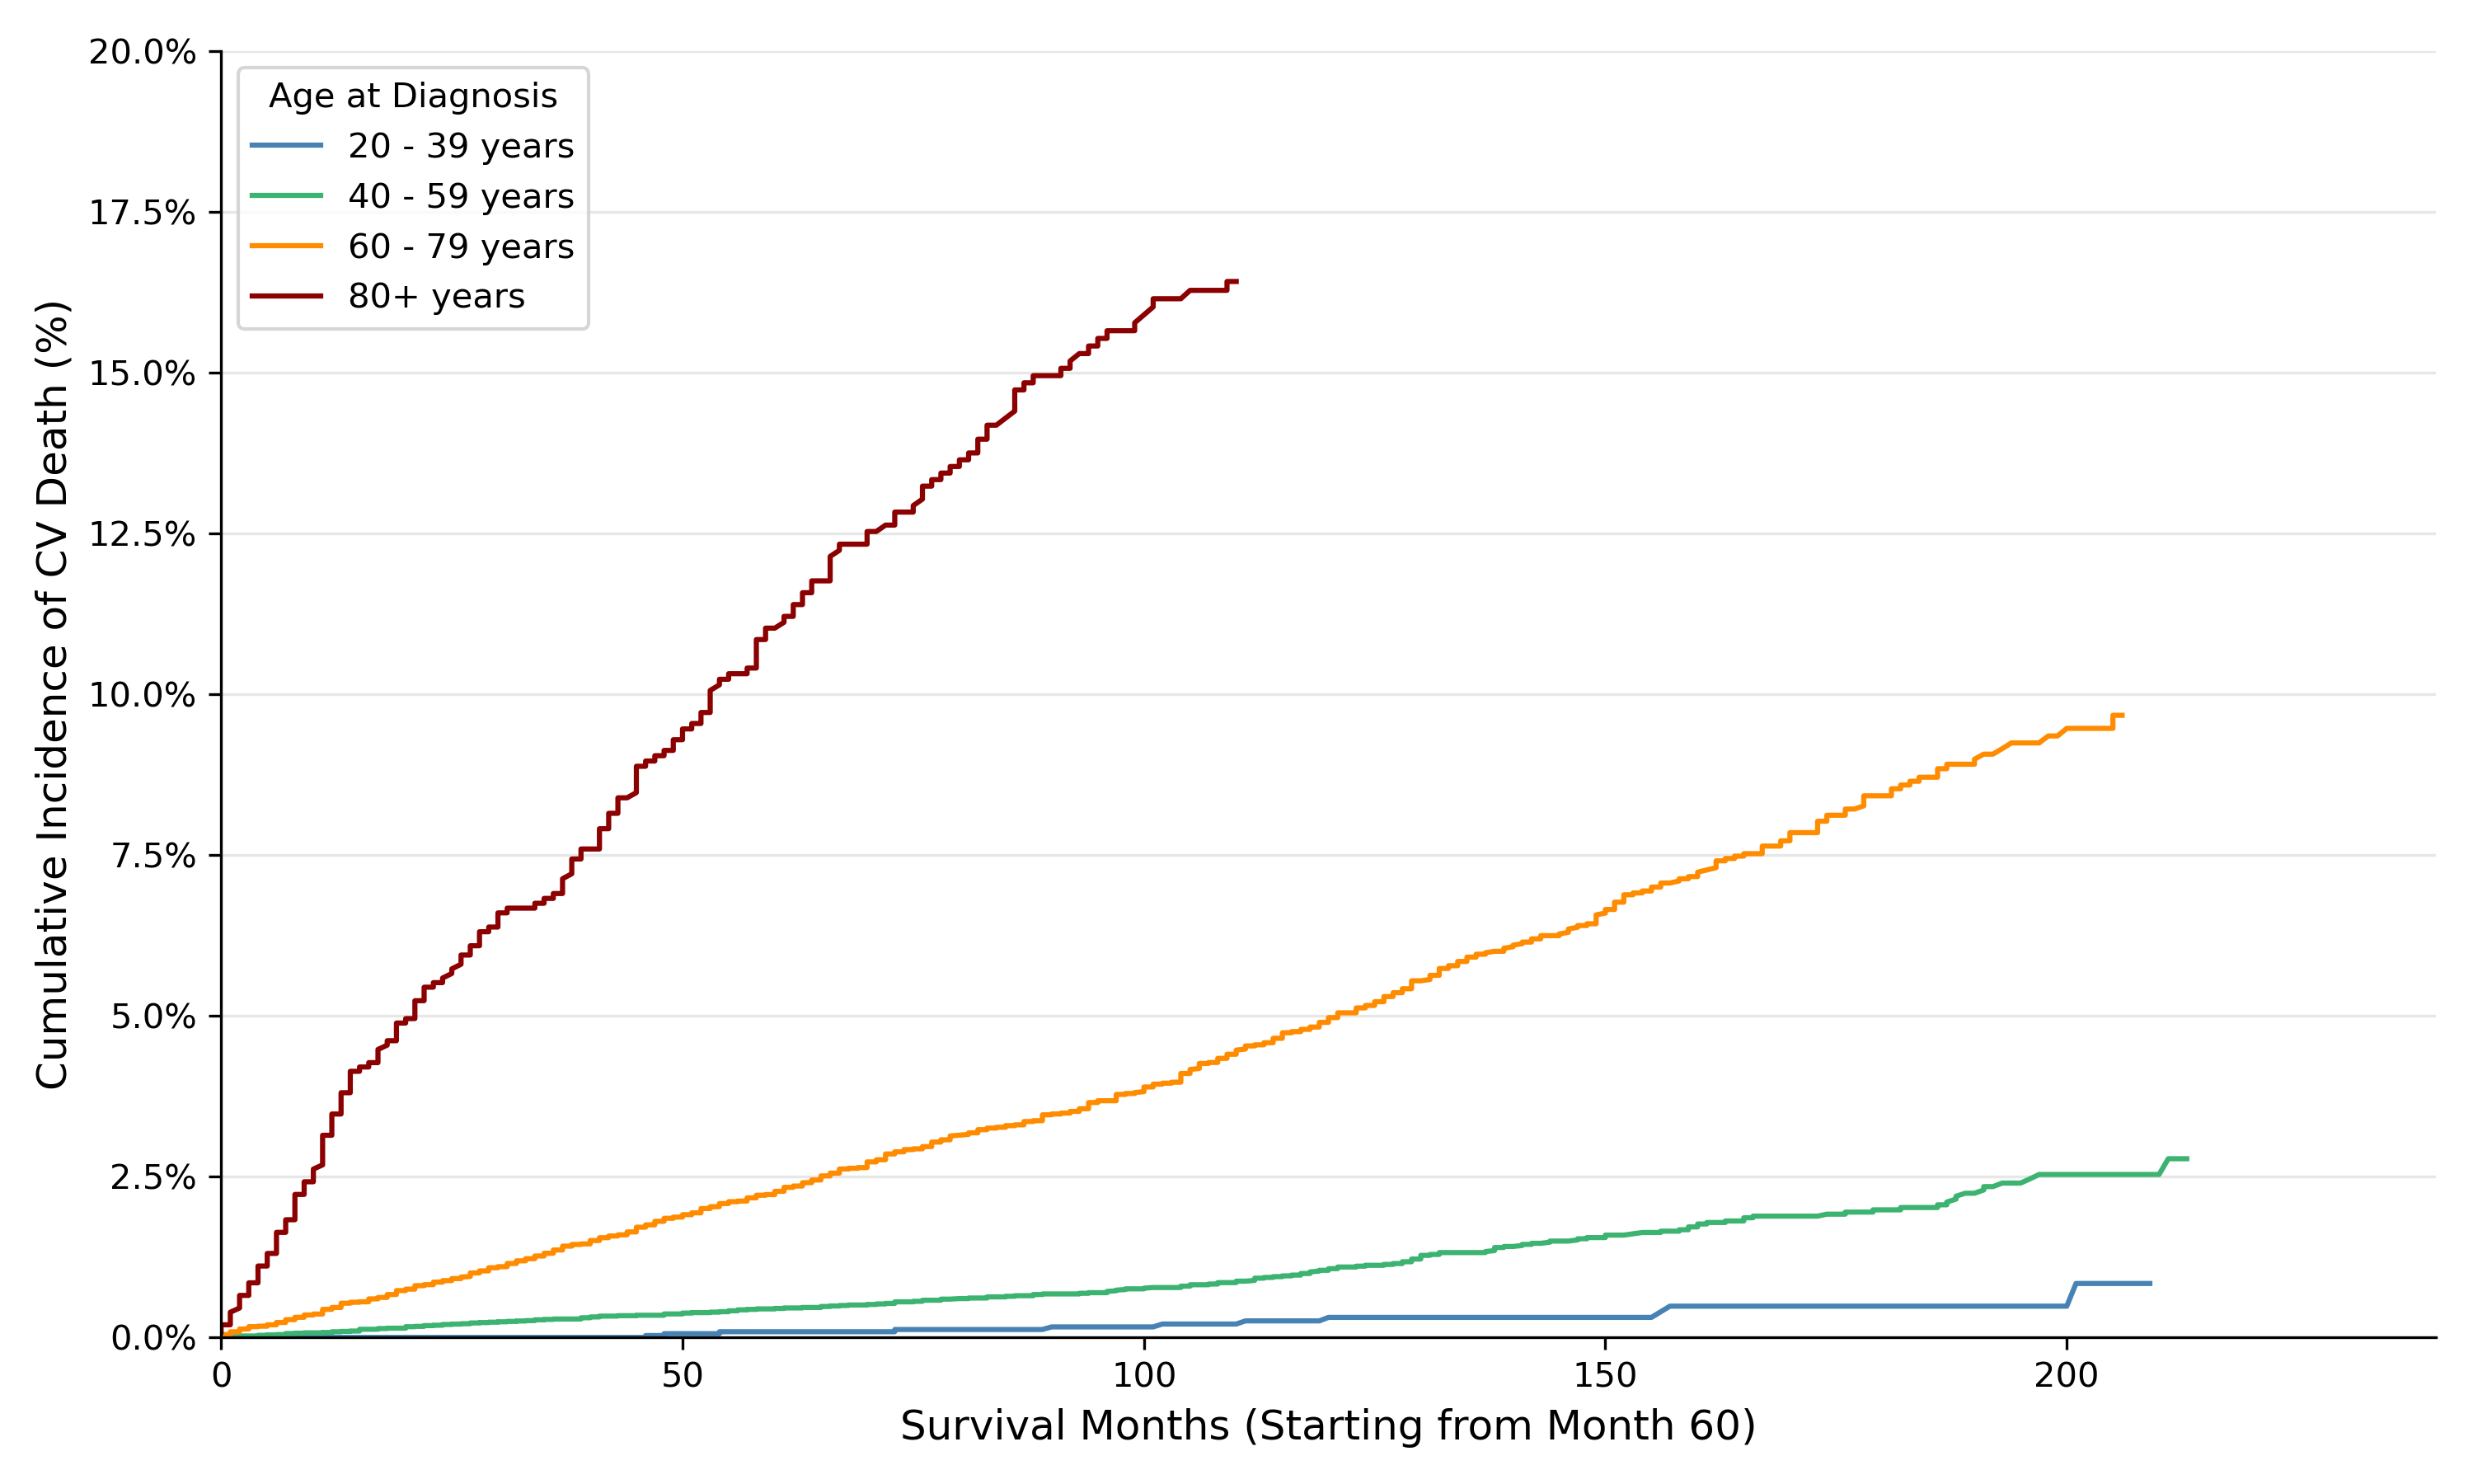
Figure 2: Cumulative Incidence of Cardiovascular Death by Age at Diagnosis

Table 2: Cumulative Incidence of Cardiovascular Mortality Among Long-term Ovarian Cancer Survivors, by Age at Diagnosis
Age at Diagnosis | Cohort Size (N) | Year 10 (60 months) | Year 15 (120 months) | Year 20 (180 months) | Final Follow-up (Months) | Final Cumulative Incidence (95% CI)
20 - 39 years | 4,401 | 0.09% | 0.31% | 0.49% | 209.0 | 0.84% (0.31 – 1.92%)
40 - 59 years | 18,403 | 0.44% | 1.06% | 1.98% | 213.0 | 2.78% (2.17 – 3.50%)
60 - 79 years | 13,811 | 2.24% | 4.93% | 8.42% | 206.0 | 9.67% (8.69 – 10.71%)
80+ years | 1,533 | 11.02% | NR^b | NR^b | 110.0 | 16.41% (14.36 – 18.58%)

Age Groups | Year 10 (60 months%) | Year 15 (120 months%) | Year 20 (180 months%)
20 - 39 years | 0.15% | 0.33% | 0.66%
40 - 59 years | 0.47% | 1.13% | 2.14%
60 - 79 years | 2.99% | 7.19% | 12.11%
80+ years | 15.21% | 23.97% | 26.95%

Table 1: Fine-Gray Subdistribution Hazard Analysis of Cardiovascular Mortality by Age
Age at Diagnosis | Subdistribution Hazard Ratio (sHR%) | 95% CI | p-value
20 - 39 years | 1.00 (Ref%) | — | —
40 - 59 years | 3.09 | 2.29 – 5.17 | <0.001
60 - 79 years | 18.74 | 13.73 – 24.84 | <0.001
80+ years | 61.83 | 45.94 – 83.22 | <0.001
* Data was shown as sHR (95% CI%). Ref, reference; sHR: subdistribution hazard ratio; CI, confidence interval

3. Cumulative Incidence of Cardiovascular Mortality Among Long-Term Female Breast Cancer Survivors, by Income
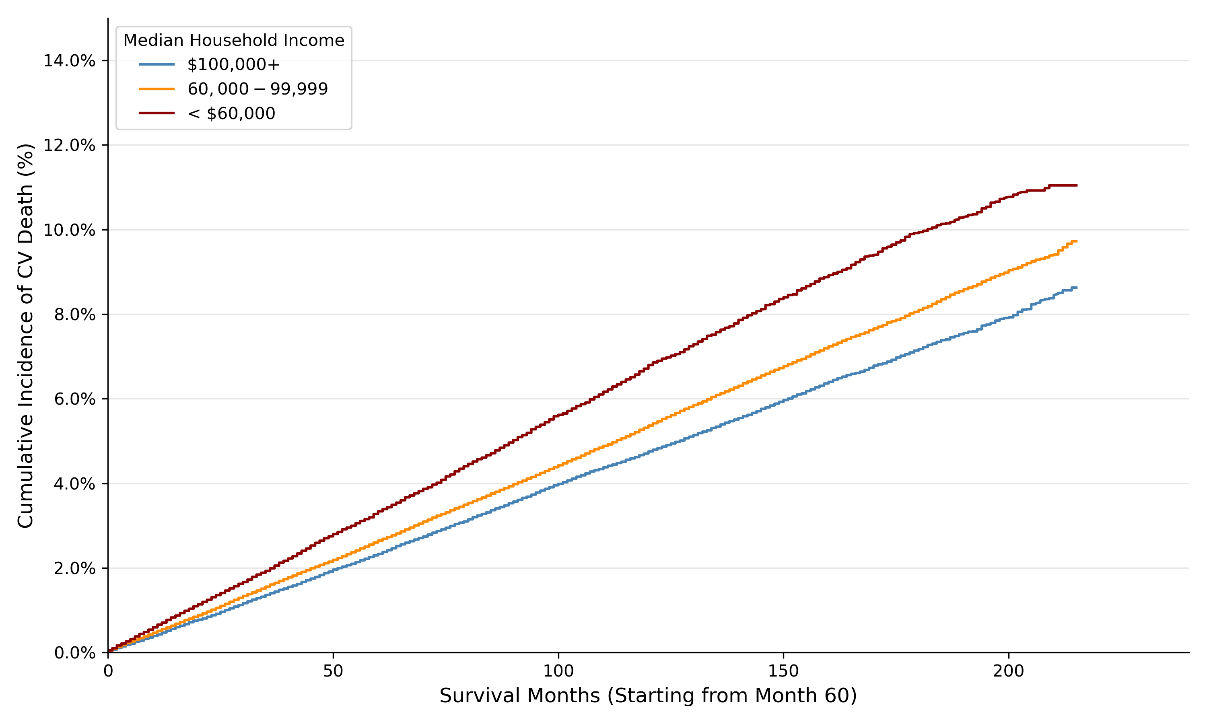
Figure 3: Cumulative Incidence of Cardiovascular Death by Income
Income Groups | Cohort Size (N%) | Final Follow-up (Months%) | Cumulative Incidence (95% CI%) | Standard Error
$100,000+ | 162,151 | 215 | 8.61% (8.29% – 8.94%%) | 0.002
$60,000 - $99,999 | 499,634 | 215 | 9.72% (8.48% – 9.96%%) | 0.001
< $60,000 | 85,857 | 215 | 11.03% (10.59% – 11.48%%) | 0.002

Cumulative Incidence post 5+ years milestones of Cardiovascular Mortality by Income:
Median Household Income | Year 10 (60 months%) | Year 15 (120 months%) | Year 20 (180 months%)
$100,000+ | 2.31% | 4.73% | 7.14%
$60,000 – $99,999 | 2.62% | 5.33% | 8.08%
< $60,000 | 3.30% | 6.76% | 9.93%

Table 2: Fine-Gray Subdistribution Hazard Analysis of Cardiovascular Mortality by Income
Median Household Income | Subdistribution Hazard Ratio (sHR%) | 95% CI | P-value
$100,000+ | 1.00 (Ref%) | — | —
$60,000 – $99,999 | 1.14 | 1.08 – 1.19 | <0.001
< $60,000 | 1.39 | 1.31 – 1.49 | <0.001
* Data was shown as sHR (95% CI%). Ref, reference; sHR: subdistribution hazard ratio; CI, confidence interval
4. Cumulative Incidence of Cardiovascular Mortality Among Long-Term Female Breast Cancer Survivors, by Race/Ethnicity
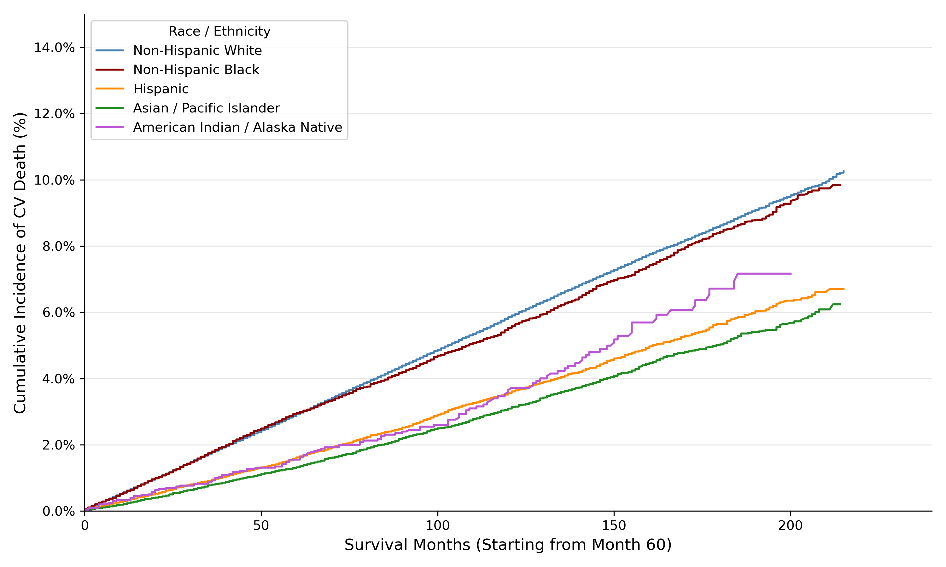
Figure 4: Cumulative Incidence of Cardiovascular Death by Race/Ethnicity

Race and Ethnicity | Cohort Size (N%) | Final Follow-up (Months%) | Cumulative Incidence (%%) | 95% CI | SE
Non-Hispanic White | 537,266 | 215 | 10.26 | 10.04 – 10.48 | 0.001
Non-Hispanic Black | 65,978 | 214 | 9.84 | 9.32 – 10.38 | 0.003
Hispanic | 77,157 | 215 | 6.7 | 6.26 – 7.15 | 0.002
Asian / Pacific Islander | 61,127 | 214 | 6.24 | 5.69 – 6.82 | 0.003
American Indian / Alaska Native | 4,030 | 200 | 7.17 | 5.80 – 8.71 | 0.007

Cumulative Incidence post 5+ years milestones of Cardiovascular Mortality by Race/Ethnicity:
Race and Ethnicity | Year 10 (60 months%) | Year 15 (120 months%) | Year 20 (180 months%)
Non-Hispanic White | 2.89% | 5.82% | 8.61%
Non-Hispanic Black | 2.93% | 5.49% | 8.41%
Hispanic | 1.60% | 3.54% | 5.64%
Asian / Pacific Islander | 1.31% | 3.07% | 5.03%
American Indian / Alaska Native | 1.55% | 3.59% | 6.71%

Table 3: Fine-Gray Subdistribution Hazard Analysis of Cardiovascular Mortality by Race and Ethnicity
Race and Ethnicity | Subdistribution Hazard Ratio (sHR%) | 95% CI | P-value
Non-Hispanic White | 1.00 (Ref%) | — | —
Non-Hispanic Black | 0.97 | 0.89 – 1.05 | 0.44
Hispanic | 0.57 | 0.52 – 0.63 | <0.001
Asian / Pacific Islander | 0.51 | 0.45 – 0.57 | <0.001
American Indian / Alaska Native | 0.6 | 0.41 – 0.90 | 0.01
* Data was shown as sHR (95% CI%). Ref, reference; sHR: subdistribution hazard ratio; CI, confidence interval

5. Cumulative Incidence of Cardiovascular Mortality Among Long-Term Female Breast Cancer Survivors, by Rural/Urban
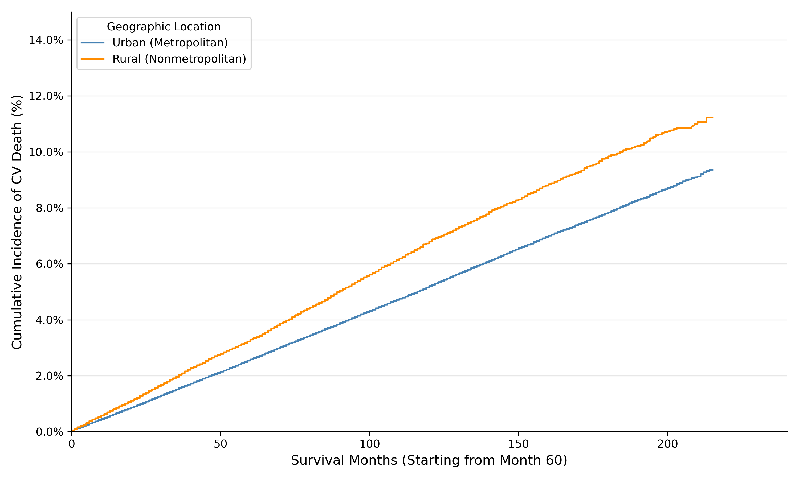
Figure 5: Cumulative Incidence of Cardiovascular Death by Geographic Location

Geographic Location | Cohort Size (N%) | Final Follow-up (Months%) | Cumulative Incidence (%%) | 95% CI | SE
Urban (Metropolitan%) | 667,548 | 215 | 9.36 | 9.18 – 9.55 | 0.001
Rural (Nonmetropolitan%) | 79,264 | 215 | 11.23 | 10.70 – 11.76 | 0.003

Cumulative Incidence post 5+ years milestones of Cardiovascular Mortality by Geographic Location:
Geographic Location | Year 10 (60 months%) | Year 15 (120 months%) | Year 20 (180 months%)
Urban (Metropolitan%) | 2.56% | 5.18% | 7.81%
Rural (Nonmetropolitan%) | 3.25% | 6.76% | 9.78%

Table 4: Fine-Gray Subdistribution Hazard Analysis of Cardiovascular Mortality by Geographic Location
Geographic Location | Subdistribution Hazard Ratio (sHR%) | 95% CI | P-value
Urban (Metropolitan%) | 1.00 (Ref%) | — | —
Rural (Nonmetropolitan%) | 1.3 | 1.21 – 1.39 | <0.001

* Data was shown as sHR (95% CI%). Ref, reference; sHR: subdistribution hazard ratio; CI, confidence interval
6. Cumulative Incidence of Cardiovascular Mortality Among Long-Term Female Breast Cancer Survivors, by Cancer Stage
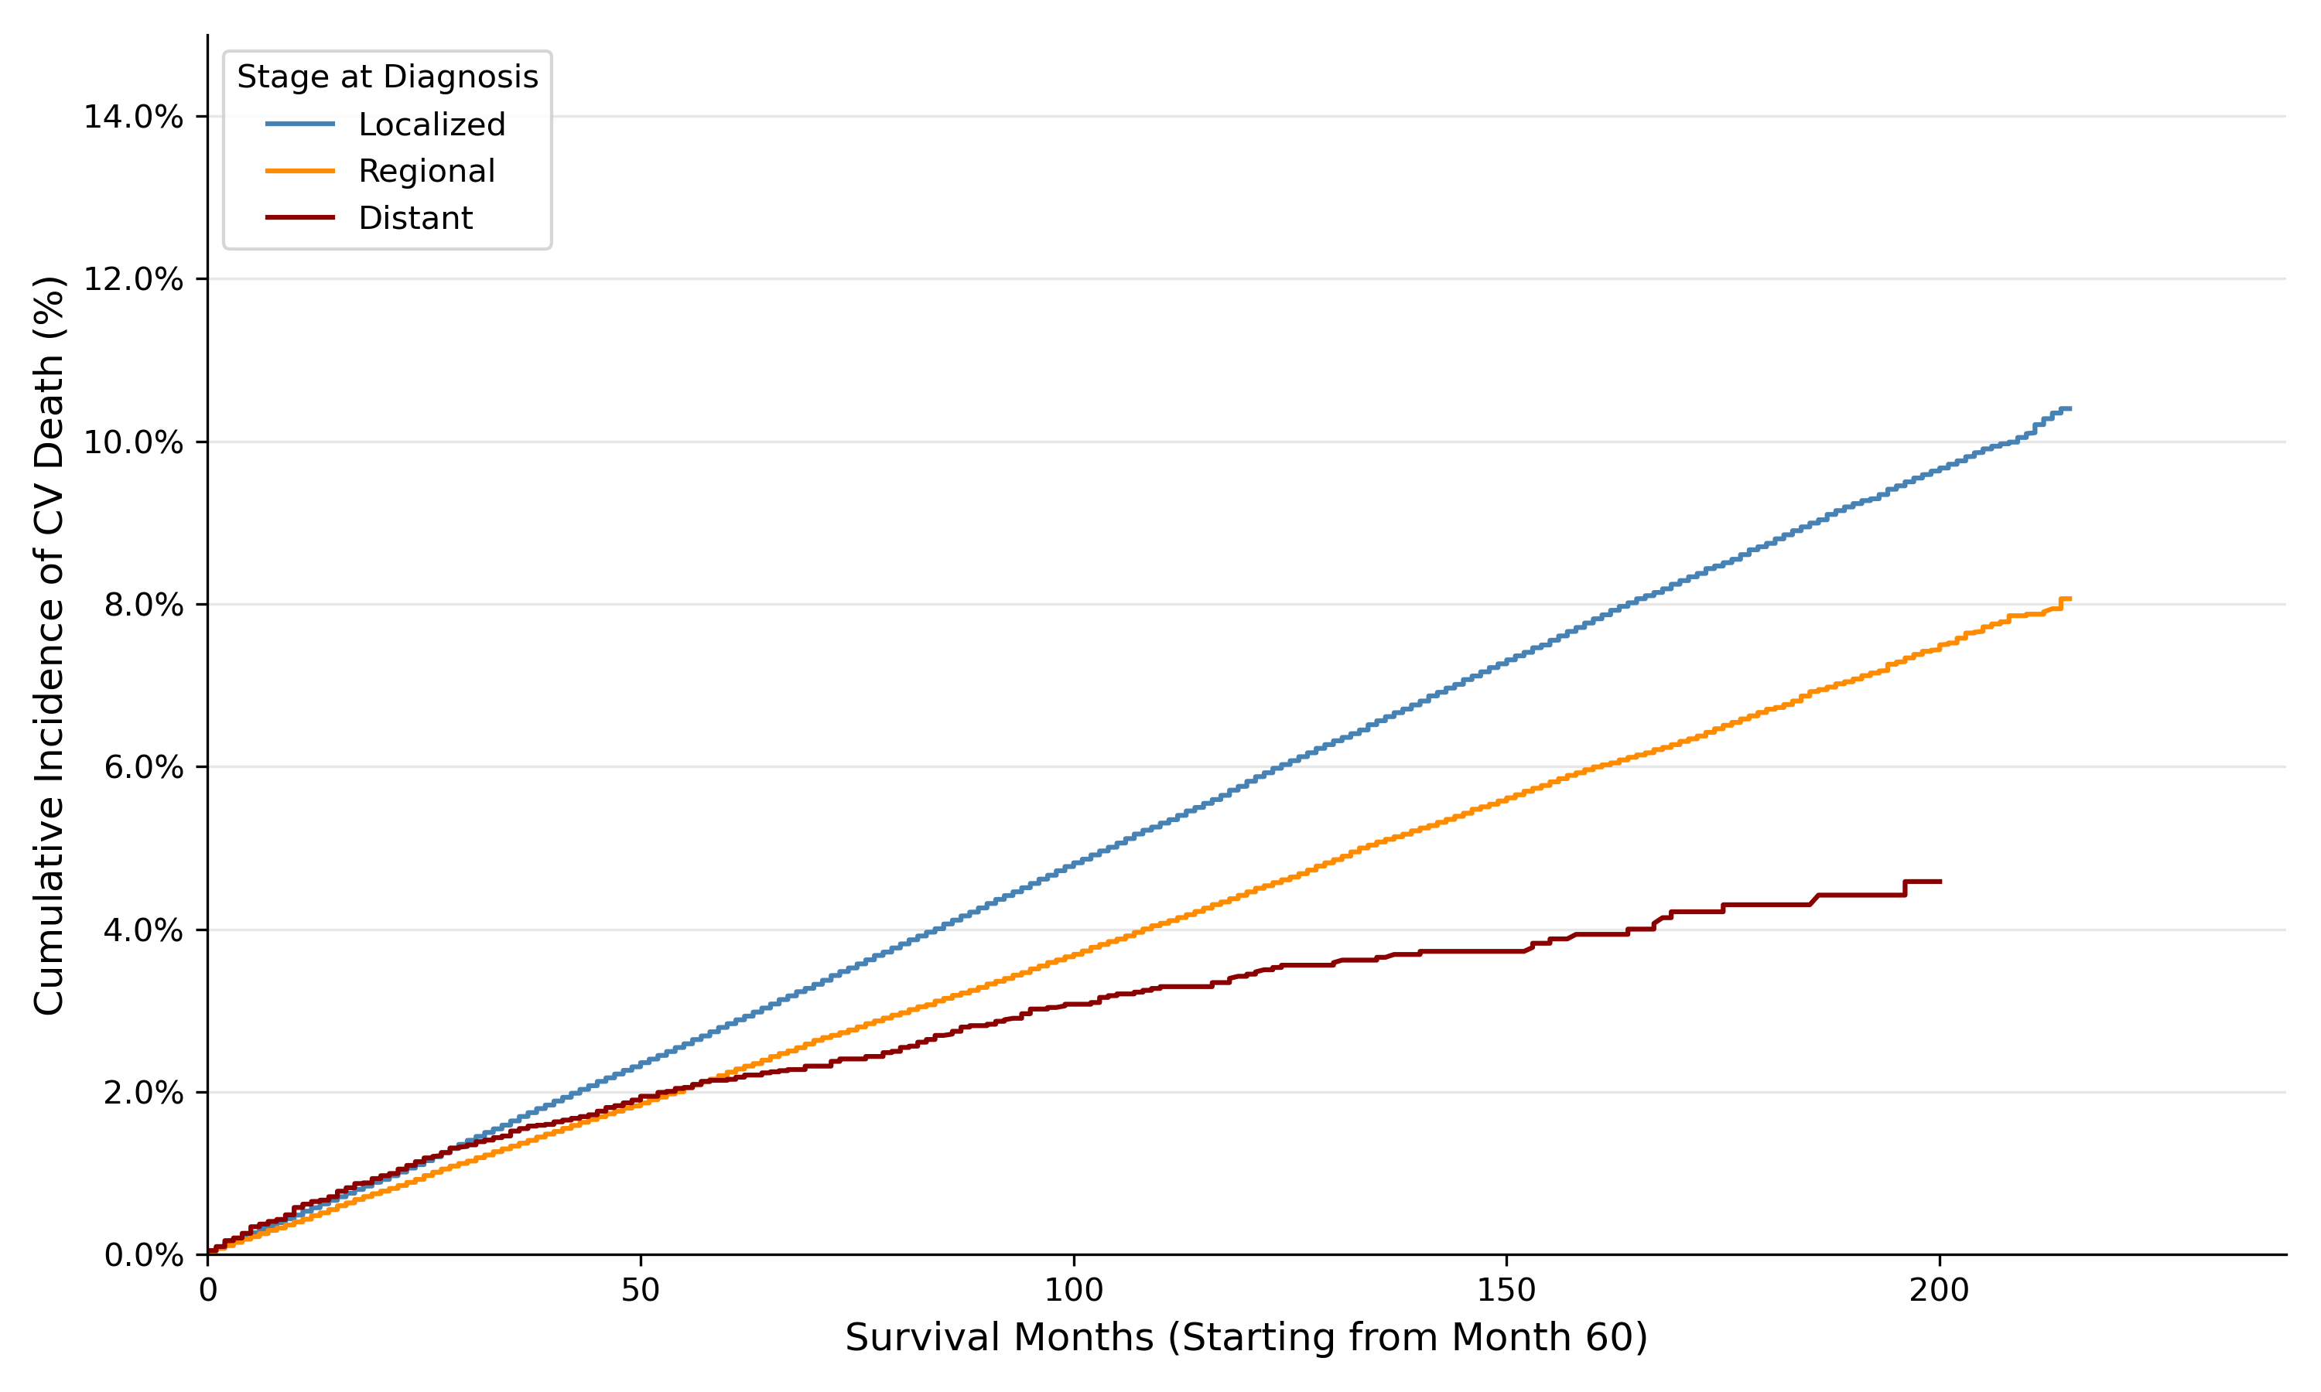
Figure 6: Cumulative Incidence of Cardiovascular Death by Cancer Stage

Stage at Diagnosis | Cohort Size (N%) | Final Follow-up (Months%) | Cumulative Incidence (%%) | 95% CI | SE
Localized | 511445 | 215 | 10.47 | 10.21 – 10.73 | 0.001
Regional | 214547 | 215 | 8.07 | 7.73 – 8.42 | 0.002
Distant | 12340 | 200 | 4.58 | 3.92 – 5.32 | 0.004

Cumulative Incidence post 5+ years milestones of Cardiovascular Mortality by Cancer Stage:
Stage at Diagnosis | Year 10 (60 months%) | Year 15 (120 months%) | Year 20 (180 months%)
Localized | 2.81% | 5.79% | 8.73%
Regional | 2.22% | 4.43% | 6.68%
Distant | 2.15% | 3.45% | 4.30%

Table 5: Fine-Gray Subdistribution Hazard Analysis of Cardiovascular Mortality by Cancer Stage
Stage at Diagnosis | Subdistribution Hazard Ratio (sHR%) | 95% CI | P-value
Localized | 1.00 (Ref%) | — | —
Regional | 0.76 | 0.72 – 0.80 | <0.001
Distant | 0.58 | 0.46 – 0.74 | <0.001

* Data was shown as sHR (95% CI%). Ref, reference; sHR: subdistribution hazard ratio; CI, confidence interval
7. Cumulative Incidence of Cardiovascular Mortality Among Long-Term Female Breast Cancer Survivors, by Cancer Treatment
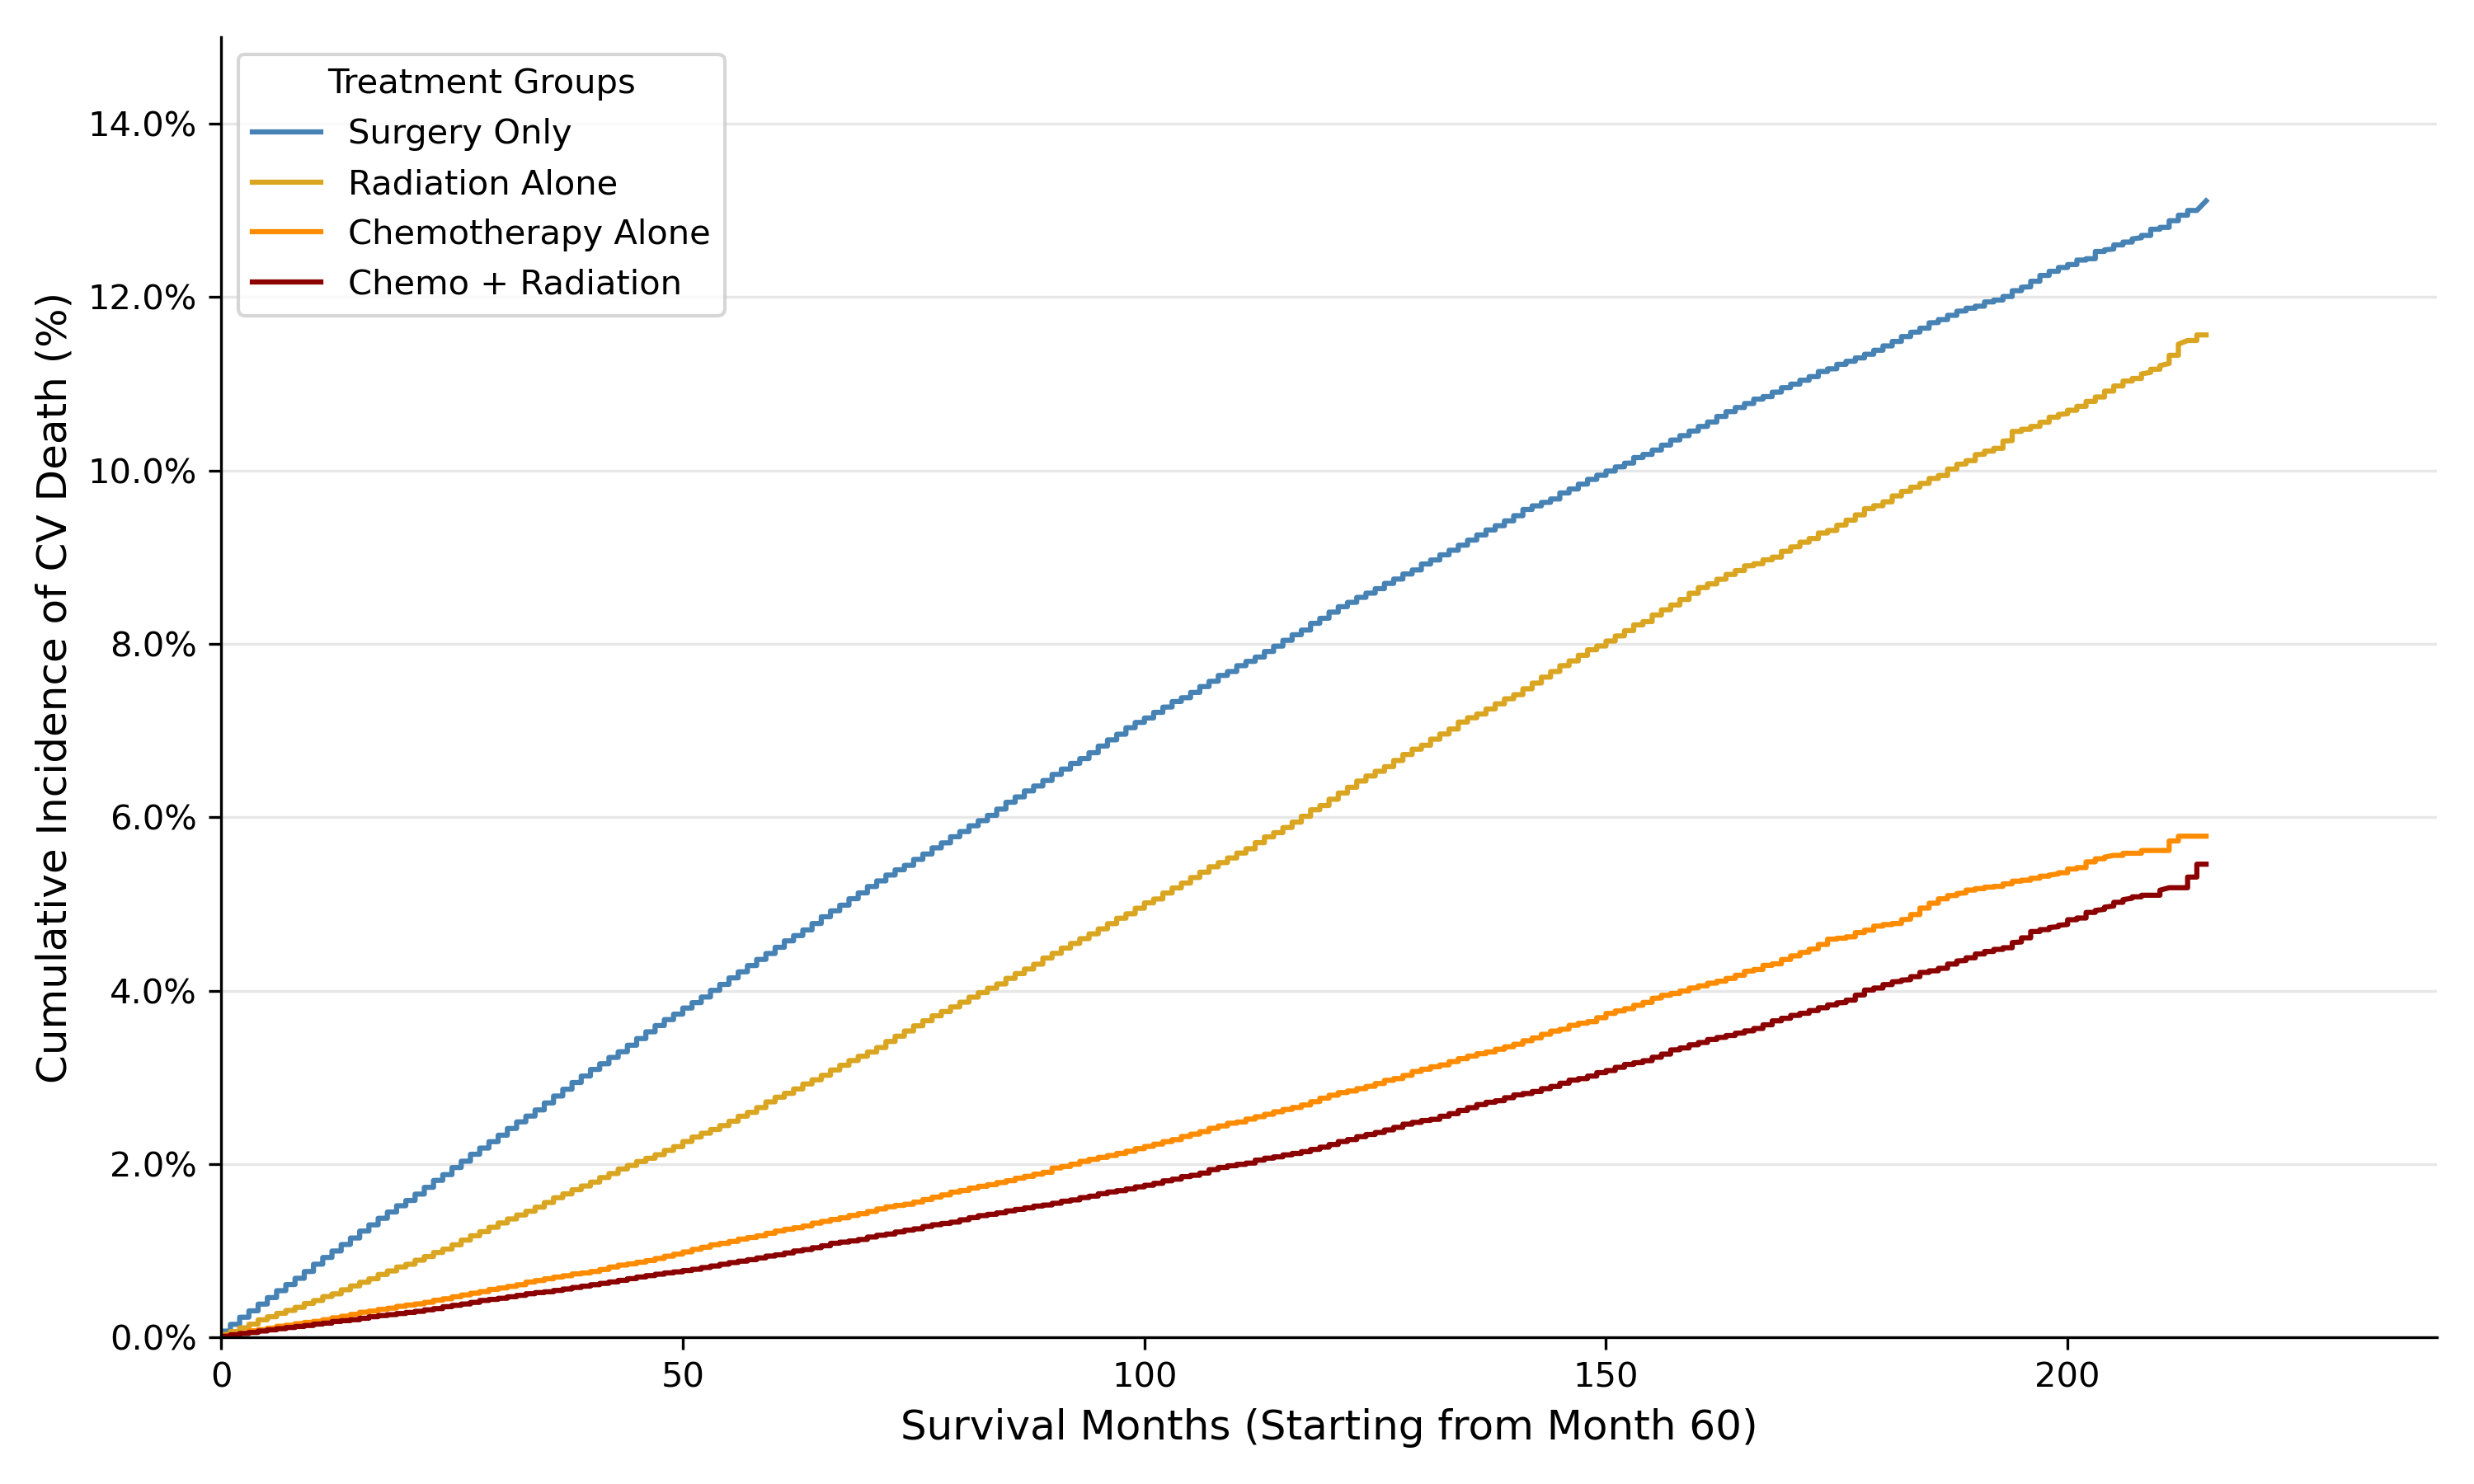
Figure 7: Cumulative Incidence of Cardiovascular Death by Cancer Treatment

Treatment Groups | Cohort Size (N%) | Final Follow-up (Months%) | Cumulative Incidence (%%) | 95% CI | SE
Surgery Only | 221,050 | 215 | 13.11 | 12.74 – 13.49 | 0.002
Radiation Alone | 211,414 | 215 | 11.56 | 11.19 – 11.94 | 0.002
Chemotherapy Alone | 125,419 | 215 | 5.78 | 5.46 – 6.12 | 0.002
Chemo + Radiation | 173,406 | 215 | 5.46 | 5.05 – 5.89 | 0.002

Cumulative Incidence post 5+ years milestones of Cardiovascular Mortality by Cancer Treatment:
Treatment Groups | Year 10 (60 months%) | Year 15 (120 months%) | Year 20 (180 months%)
Surgery Only | 4.46% | 8.33% | 11.41%
Radiation Alone | 2.75% | 6.17% | 9.61%
Chemotherapy Alone | 1.21% | 2.77% | 4.76%
Chemo + Radiation | 0.94% | 2.21% | 4.05%

Table 6: Fine-Gray Subdistribution Hazard Analysis of Cardiovascular Mortality by Cancer Treatment
Treatment Groups | Subdistribution Hazard Ratio (sHR%) | 95% CI | P-value
Surgery Only | 1.00 (Ref%) | — | —
Radiation Alone | 0.71 | 0.67 – 0.75 | <0.001
Chemotherapy Alone | 0.33 | 0.30 – 0.36 | <0.001
Chemo + Radiation | 0.29 | 0.27 – 0.31 | <0.001

* Data was shown as sHR (95% CI%). Ref, reference; sHR: subdistribution hazard ratio; CI, confidence interval
8. Cumulative Incidence of Cardiovascular Mortality Among Long-Term Female Breast Cancer Survivors, in Radiation-Exposed groups by Tumor Laterality
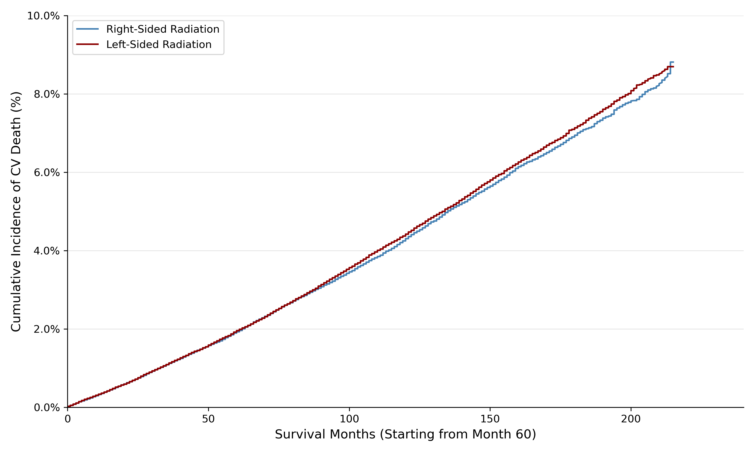
Figure 8: Cumulative Incidence of Cardiovascular Death in Radiation-Exposed Groups by Laterality
Laterality | Cohort Size (N%) | Final Follow-up (Months%) | Cumulative Incidence (%%) | 95% CI | SE
Right-Sided Radiation | 190,518 | 215 | 8.81 | 8.28 – 9.36 | 0.003
Left-Sided Radiation | 193,943 | 215 | 8.69 | 8.37 – 9.02 | 0.002

Cumulative Incidence post 5+ years milestones of Cardiovascular Mortality in Radiation-Exposed Groups by Laterality:
Laterality | Year 10 (60 months%) | Year 15 (120 months%) | Year 20 (180 months%)
Right-Sided Radiation | 1.91% | 4.27% | 6.92%
Left-Sided Radiation | 1.93% | 4.40% | 7.12%

Table 7: Fine-Gray Subdistribution Hazard Analysis of Cardiovascular Mortality in Radiation-Exposed Groups by Laterality
Laterality | Subdistribution Hazard Ratio (sHR%) | 95% CI | P-value
Right-Sided Radiation | 1.00 (Ref%) | — | —
Left-Sided Radiation | 1.05 | 0.97 – 1.13 | 0.21

* Data was shown as sHR (95% CI%). Ref, reference; sHR: subdistribution hazard ratio; CI, confidence interval

Study Population
We conducted a retrospective, cohort study examining the incidence of cardiovascular disease (CVD%) mortality among long-term female breast cancer survivors. The data was obtained from the Surveillance, Epidemiology, and End Results (SEER%) database. We limited our population to women diagnosed with a first primary, invasive breast cancer (localized, regional, or distant stage%) who survived 60 months or more (5+ years%) post-diagnosis. We evaluated patients across key demographic, socioeconomic, and clinical categories, including age at diagnosis, median household income, race and ethnicity (Non-Hispanic White, Non-Hispanic Black, Hispanic, Asian/Pacific Islander, and American Indian/Alaska Native%), geographic location (urban/metropolitan vs rural/nonmetropolitan%), and cancer stage. Patients with unknown, unstaged, or missing data for a respective variable of interest were excluded from that specific analysis. Information regarding survival time and cause of death was obtained through the SEER cause-specific death classification variables.

Treatment Analysis
We classified women according to their primary breast cancer treatment, surgery only (women who received surgical resection but no or unknown history of chemotherapy or radiotherapy%), chemotherapy alone (women who received chemotherapy, with or without surgery, but had no or unknown history of radiotherapy%), chemotherapy plus radiotherapy (women who received both chemotherapy and radiotherapy, with or without surgery%), and radiotherapy alone (women who received radiotherapy, with or without surgery, but had no or unknown history of chemotherapy%). Patients who received no active treatment, or those with unknown treatment statuses, were excluded from the treatment analysis. Furthermore, to evaluate the potential anatomical cardiotoxicity of radiation therapy, we conducted a targeted subgroup analysis strictly restricted to the radiation-exposed cohort (combining the 'radiotherapy alone' and 'chemotherapy plus radiotherapy' groups%), stratified by the laterality of the primary tumor (left-sided vs right-sided%).

Statistical Analysis
To quantify the absolute risk of Cardiovascular Disease (CVD%) mortality, we conducted a competing risks analysis using the Aalen-Johansen estimator to calculate cumulative incidence. All non-CVD related deaths, including breast cancer-specific mortality and other non-cancer causes, were strictly treated as competing events. Cumulative incidence were extracted at 10, 15, and 20 years post-survivorship (i.e., 60, 120, and 180 months from the 5-year survivorship mark%). To ensure statistical stability and prevent tail-end artifacting, final incidence estimates and their corresponding 95% confidence intervals (CIs%) were dynamically truncated when the number of at-risk individuals dropped below 100. All unadjusted incidence analyses and visualizations were conducted using Python 3.13.12 (using the lifelines package%).
To evaluate the independent mathematical effect of demographic, socioeconomic, and clinical variables on CVD mortality while accounting for competing risks, we constructed Fine-Gray proportional subdistribution hazard models. This approach generated Subdistribution Hazard Ratios (sHRs%) and 95% CIs. Reference groups were established for each univariable model (e.g., Non-Hispanic White for race, surgery only for treatment, etc%). Furthermore, to evaluate anatomical cardiotoxicity, a targeted laterality analysis (left-sided versus right-sided tumors%) was conducted strictly within the radiation-exposed cohort. Competing risk hazard modeling was performed using Rstudio version 4.3.3 (using the survival package%).

